Fingerboard

Bridge
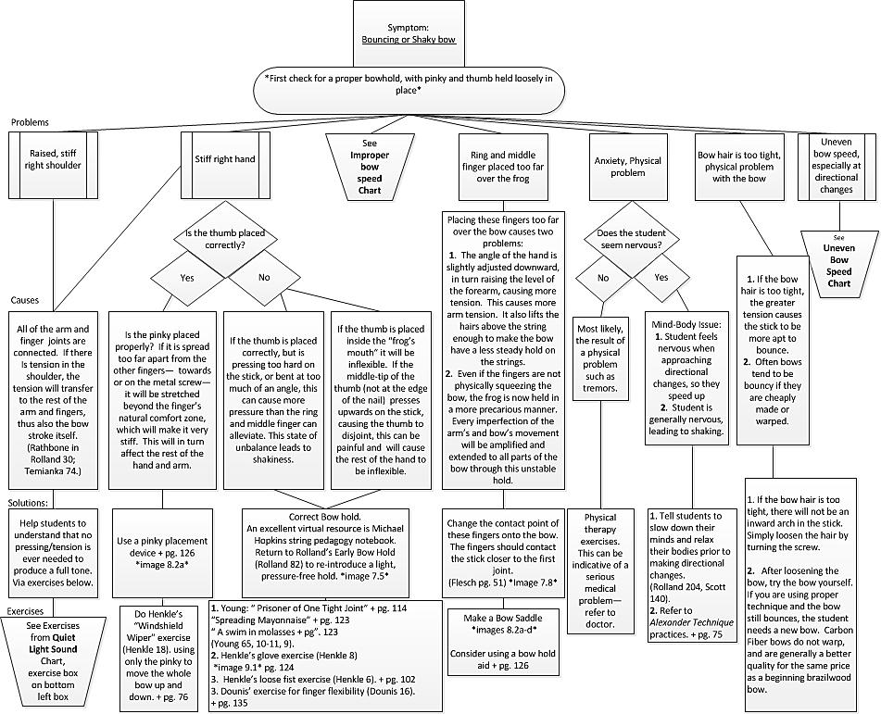
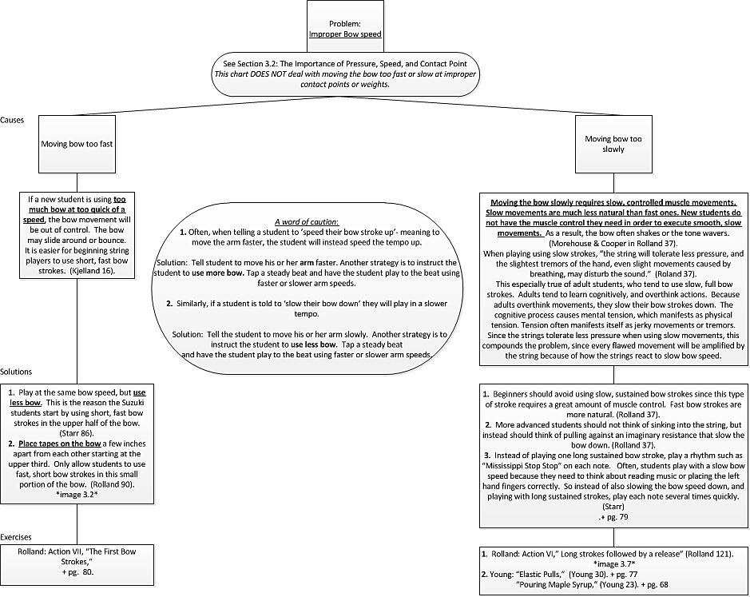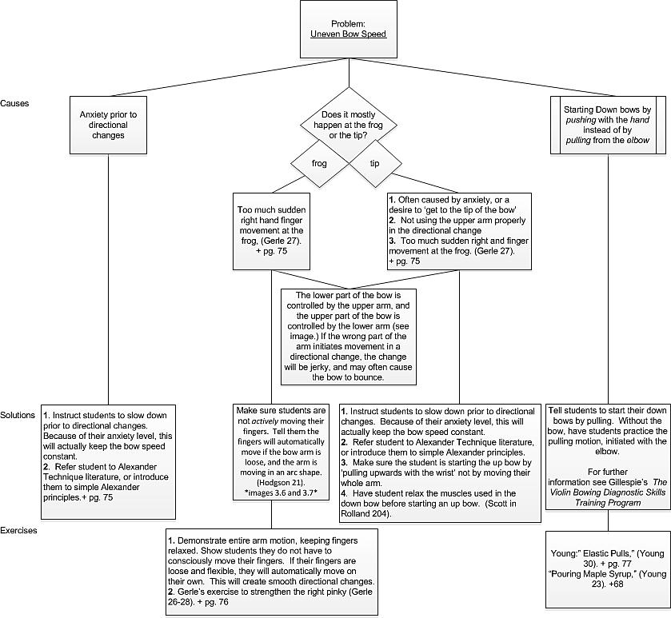

References:
Books written for violinists:
Leopold Auer, Violin Playing as I Teach it.
Simon Fischer, Basics: 300 Exercises and Practice Routines for the Violin.
*Carl Flesch, Problems of Tone Production in Violin Playing.
Carl Flesch, The Art of Violin Playing.
Ivan Galamian, Principles of Violin Playing and Teaching.
Kato Havas, The Twelve Lesson Course.
*Susan Kempter, How Muscles Learn: Teaching the Violin with the Body in Mind.
Leopold Mozart, A Treatise on the Fundamental Principles of Violin Playing.
*Paul Rolland, The Teaching of Action in String Playing: Violin and Viola.
*William Starr, The Suzuki Violinist: a Guide for Teachers and Parents.
*Phyllis Young, The String Play: the Drama of Playing and Teaching Strings.

Texts written for non-string playing teachers: (but useful for string playing teachers too)
Robert Gillespie and Donald Hamann, Strategies for Teaching Strings: Building a Successful String and Orchestra Program.
Robert Gillespie, The Violin Bowing Diagnostic Skills Training Program.
Robert Gillespie, The Violin Left Hand and Instrument Position Diagnostic Skills Training Program.
Elizabeth Green, Teaching Stringed Instruments in Classes.
Ted Henkle, The String Teacher's Handbook.
*James Kjelland, Orchestral Bowings: Style and Function.
*James Kjelland, “String-O-Phobia: Some Causes and Cures.”
Robert Klotman, Teaching Strings.
Wolfgang Kuhn, The Strings.
Norman Lamb, Guide to Teaching Strings.
Vincent Oddo, Playing and Teaching the Strings.
Scientific Texts:
Kaare Bolgen, The Science of Violin Playing: Edited for Amateurs.
*Robert Gerle, The Art of Bowing Practice: The Expressive Bow Technique.
*Percival Hodgson, Motion Study and Violin Bowing.
Arthur Jahn, Die Grundlagen der Natürlichen Bogenführung auf der Violine (Fundamentals of Natural Bowing on the Violin).
Karl Klinger, Über die Grundlagen des Violinspiels (On the Fundamentals of Violin Playing).
*Georg Mertens, An Objective Analysis of Bow Technique.
*Ottó Szende, and Mihály Nemessuri, The Physiology of Violin Playing.
Frederick Polnauer, Senso-Motor Study and its Application to Violin Playing.
*Friedrich Steinhausen, Die Physiologie der Bogenführung auf den Streich-Instrumenten (The Physiology of Bowing on Stringed-Instruments).
Wilhelm Trendelenurg, Die natürlichen Grundlagen der Kunst des Streichinstrumentenspiels (The Natural Fundamentals of the Art of Playing String Instruments).
Julius Winkler Die Technik des Geigenspiels (The Technic of Violin Playing).

